Final Suggestions for Optimization & Branding

1. Developer Portfolio PDFs
Objective: Create individual, skill-focused portfolios for each developer in two visually appealing formats:
- Version 1: Document-style (clean, minimal)
- Version 2: PPT-style (graphical and visual-heavy)
Both to be exported as PDFs with light graphic design.
Purpose:
These portfolios will replace plain images and links on platforms like LinkedIn, Upwork, and personal sites — making it easier to showcase skills, past projects, and client results in a professional way.
Reference Example:
Paula Braiden Portfolio on LinkedIn

2. Newsletter Creation
Action Plan:
- Harvest contact info and project details from previous clients
- Build a segmented database for:
  - Post-project updates
  - New service offerings
  - Seasonal promotions
  - Reactivation of old clients
Goal: Boost long-term marketing and retention through consistent value-driven email campaigns.

3. Developer Upwork Achievements → LinkedIn Sharing
Why:
Sharing Upwork success (Top Rated, JSS %, major client wins) on LinkedIn boosts:
- Personal branding
- Visibility among organic leads
- LinkedIn-to-Upwork client flow
Example Posts:
- “Just completed a $10k+ milestone with 5-star feedback!”
- “Currently ranked Top 10% ReactJS Devs on Upwork – thanks to all amazing clients!”

4. Client Reactivation via Reviews
Observation:
Rohail's ID shows ~34 projects, but only 5–6 received proper client reviews.
Opportunity:
Use review follow-up as a way to re-engage old clients:
- “We’re improving our Upwork profile. Would love your feedback if you enjoyed working with us.”
- "Also, let me know if you have any new work – we'd love to help again!”

5. Proposal Quality Review
Issue Noted:
Some submitted proposals were weak, lacked personalization, or used outdated images and GitHub links.
Immediate Fixes:
- Refresh developer GitHub profiles
- Update visuals used in attachments
- Craft stronger, more tailored proposals using success templates
  - Avoid generic intros
  - Include relevant case studies & CTA
Old Example (Needs Update):
Upwork Proposal – Image Outdated
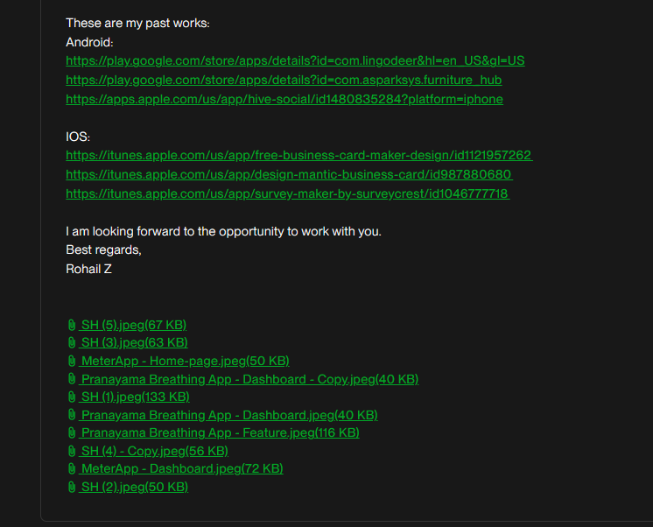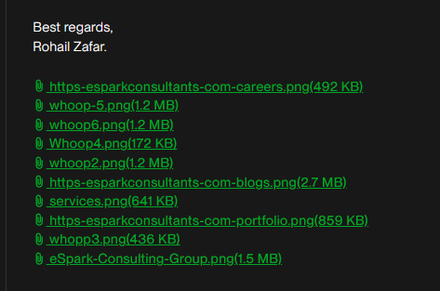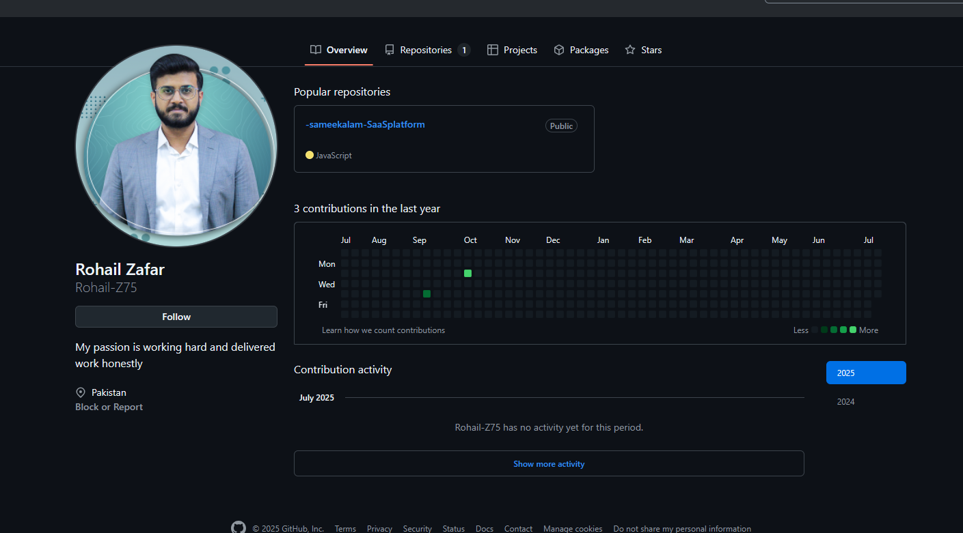
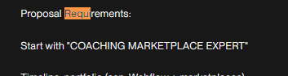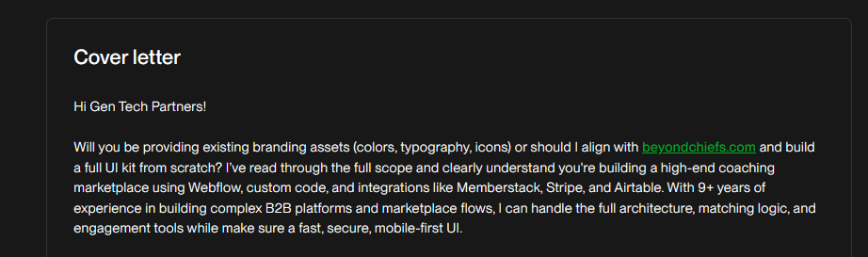
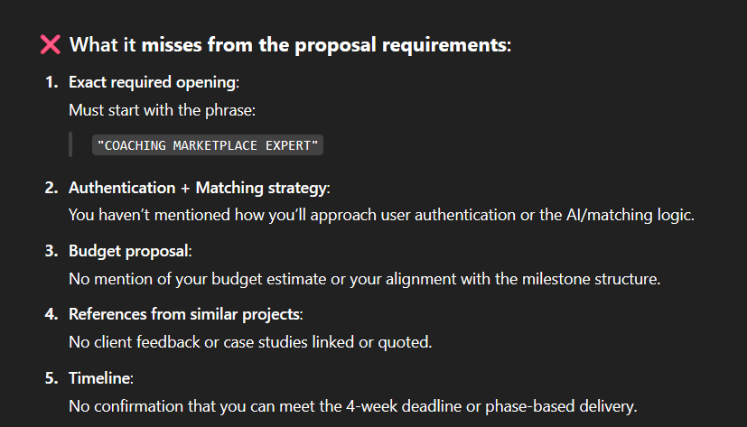

6. Bidding Workflow & Ticket Management
Platform Recommendation: GitHub Issues
Plan:
Set up a ticket-based system to manage bidding progress across all leads and bidders.
Benefits:
- One GitHub issue = one lead/client
- All messages, updates, and tasks go into a single thread
- Fully trackable communication → reduces miscommunication or blame-shifting
- Enables review/audit of project lifecycle at any time
To Implement:
- GitHub Project board (Kanban style) with custom fields for:
  - Lead stage (New → Proposal Sent → In Talks → Closed)
  - Assigned bidder
  - Value estimate
  - Client platform (Upwork, LinkedIn, etc.)

Additional Suggestions

7. Standardized Developer Bios
Develop short bios for each team member to use in proposals, profile descriptions, and team introductions. Each bio should include:
- Tech stack
- Highlighted client experience
- Industry focus (e.g., SaaS, eCommerce)
- Social proof and certification highlights

8. Developer Video Introductions
Record 60–90 second video intros for each developer. Include who they are, what they specialize in, and one strong project result. Host privately on YouTube or Loom and use them in proposals and LinkedIn profiles.

9. Monthly LinkedIn Highlight Posts
Publish a structured post from the company or founder’s account showcasing:
- New wins
- Testimonials
- Available developers
- Open to work message or collaboration CTA
Helps maintain visibility and warm leads.

10. Visual Case Studies
Build case studies of top 3–5 projects. Each case study should include:
- Problem statement
- Technical solution
- Process followed
- Results achieved
- Client feedback (if available)
Output both as PDF (for proposals) and carousel (for LinkedIn).

11. Proposal SOP and Template Bank
Establish a shared SOP for writing effective proposals. Include:
- Lead analysis checklist
- Strong intro examples
- Answer templates for common Upwork questions
- Ready-to-use case studies and image attachments

12. Client Qualification Framework
Avoid wasting time on low-quality jobs. Implement a checklist to qualify leads based on:
- Budget size and clarity
- Client hiring history
- Scope quality
- Platform history (Upwork or otherwise)
Score leads 1–5 and prioritize accordingly.

13. End-of-Project Review Flow
Introduce a post-delivery process to gather reviews:
- Deliver final project output
- Thank the client and request feedback
- Follow up with a reminder if needed
- Offer minor bonus support or revisions for cooperative clients

14. LinkedIn Recommendations
Reach out to satisfied clients from major projects and ask for LinkedIn recommendations. Offer to send a draft for convenience. This will act as public, verifiable social proof.

15. Skills Landing Pages or Notion Index
Create a simple, clean landing page or Notion workspace with categorized services such as:
- ReactJS Development
- WordPress Optimization
- SEO & Core Web Vitals
- API and CRM Integrations
- Audit and Strategy Consulting
Use this to pitch specific services and internally assign the right team members.

16. Internal Developer Availability Tracker
Maintain a live dashboard (in Notion, Airtable, or Google Sheets) that shows:
- Developer name and skill focus
- Current availability (Free, Partial, Busy)
- Weekly capacity
- Upcoming planned leaves or overload risk
Streamlines resourcing and avoids scheduling conflicts.

17. Lead Management Automation
Use tools like Zapier or Make to automate:
- Saving new Upwork jobs to GitHub/Notion
- Sending reminders for follow-ups
- Triggering Slack or email updates for proposal submission and review responses

18. Client Onboarding Document
Design a short onboarding guide for new clients including:
- Introduction to the team
- Tools and communication channels
- Expected timelines
- Feedback and revision process
- Payment and project tracking details
Helps clients know what to expect and reduces friction.

Let me know if you'd like this exported as a company SOP, Notion workspace, or PDF guideline. I can also help build the portfolio templates, review scripts, and internal dashboards.

